Resistors in Series and Parallel

Equipment Needed

Power Supply, Fisher-EMD S44175-1 Battery Eliminator
Resistance Board, Clear Plastic (100Ω, 330Ω, and 560Ω resistors)
Lead, Banana/Banana (7)
Multi-Meter, Digital (DMM) (2)
Probes, for Multi-Meter, Digital

Note: The resistor colors are br bk br, o o br, and g bu br. The document ‘How to Read Resistor Codes’ is on the last page of this lab.

Objective
In this lab we will quantitatively investigate the equivalent resistance of resistors added in series and parallel as well as the behavior of circuits wired in parallel or series.

Combinations of Series and Parallel Resistors—(Theory Section)
Once we have established Ohm’s Law, a question that arises quite naturally is “What happens if we connect several resistors together?” We can connect resistors in one of two ways. If we connect them one after another as shown in Figure 1, we say that they are connected in series. If we connect them so that the ends are joined together in pairs as shown in Figure 2, we say that the resistors are connected in parallel.
Figure 1 Resistors connected in Series
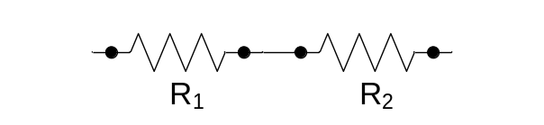
Figure 2 Resistors connected in Parallel
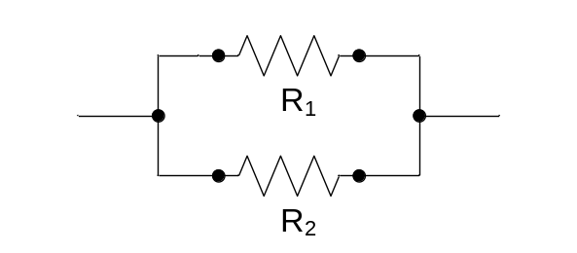
We now want to consider equivalent resistances when resistors are placed in series and/or parallel. To understand this we need to understand some properties of potential difference and current better. First if there is only one path for the current to follow such as the series circuit shown in Figure 3, then the current has to have the same value everywhere in the circuit.
Figure 3 Series Resistor circuit
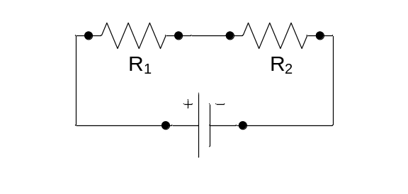
If it didn’t, charge would accumulate at various points in the circuit causing electric fields that would alter how the current flows in the circuit.
The second thing we need to know is that the potential difference across the circuit must be equal to the potential difference supplied by the power supply. Note that we need to account for all of the resistance including any internal resistance of the power supply for this conclusion to be accurate. In this experiment, the resistors we will be using are large compared to the internal resistance of the power supply and consequently we will neglect the internal resistance of the power supply. If we let 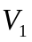 be the potential difference across 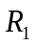, 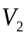 be the potential difference across 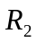, and V be the potential difference supplied by the power supply then
If we apply Ohm’s Law to calculate the potential difference across each of the resistors and use the fact that the current is the same through each resistor we obtain
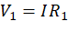
and

Giving us for the sum of the potential drops across each of the resistors
Equation 1
We define the equivalent resistance of the circuit shown in Figure 3 as
.
Dividing both sides of Equation 1 by I yields
Equation 2
When we add resistors in series the equivalent resistance is simply the sum of the individual resistors.
A parallel resistor circuit is shown in Figure 4.
Figure 4 Parallel resistive network
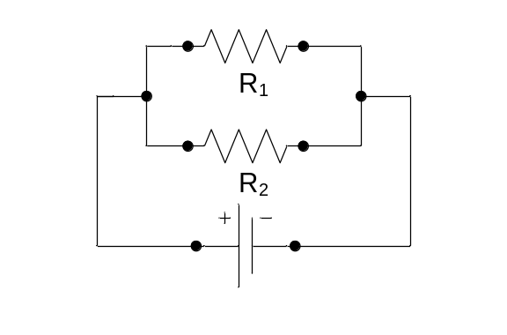
In order to understand how the resistors add in this circuit, we need to know a few more facts about the behavior of potential difference and current in this type of circuit. The elements in a circuit are usually connected by wire with very low resistance. We typically neglect the resistance of the wires connecting the various elements and assume that current flows through the wires connecting the circuit elements without any potential drops. Thus when we have resistors connected in parallel across a power supply as shown in Figure 4, the potential difference across each resistor is equal to that supplied by the power supply. What about the current? A current I flows out of the power supply. Let 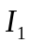 be the current flowing through and let 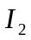 be the current flowing through . The sum of the currents flowing in the resistors must be equal to that supplied by the power supply. If it weren’t charge would build up somewhere in the circuit creating an electric field which would alter how the charge flowed. Thus for the current flowing in the parallel circuit we can write
If we make use of Ohm’s Law, we can calculate the current flowing in each of the resistors in terms of the potential difference supplied by the power supply we obtain
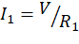 and
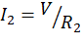
Adding these currents together we can write
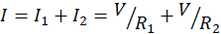
We can define the equivalent resistance for the parallel resistive circuit by
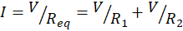 Equation 3
If we divide both sides of Equation 3 by V we obtain
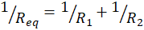 Equation 4
In parallel circuits, the reciprocals of the resistance add. We will now investigate how resistors add in series and parallel and how these combinations of resistors behave. We will place these resistors in series and parallel circuits and measure the currents and potential differences in the circuits, comparing them to predictions based on Equations 1 thru 4.

Procedure
In this part of the lab we will connect a series combination of resistors and a parallel combination of resistors and compare the measured value of the equivalent resistance to the values we calculate from individually measured values. Resistors are marked with color bands that denote a nominal value.
Preliminary
- Read the bands on the three resistors and determine their nominal value.
- Set the DMM to measure resistance.
- Measure the resistance of each resistor to see what the actual measured value of the resistor is.
Table 1
 | Color Bands | Nominal Ω | Measured Ω

Part I Resistors in Series
Equivalent Resistance
Measuring with DMM (Digital Multimeter)
Figure 6 Measurement of the equivalent resistance in the series circuit
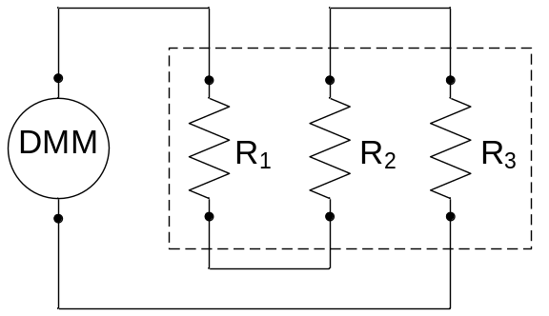
- Set the DMM to measure resistance.
- Connect the three resistors so that they are connected in series with the DMM (set to ohms) as shown in Figure 6.
- What is the measured equivalent resistance of the three resistors. _______________
- Add the measured resistances in Table 1.
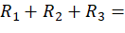 _______________
- How do the values in Question 3 and Question 4 compare? What is their percent difference?
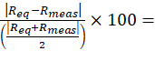 _______________%
- Of the four numbered equations (in the Theory Section), which one applies here? _______________

Resistors in a Series Circuit
Figure 7 DC Series Resistor Circuit
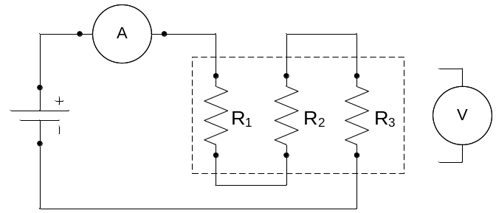

- Connect the three resistors, the ammeter, and the battery eliminator in series as shown in Figure 7.
  - The ammeter should be set in the 200mADC scale.
  - Set the battery eliminator ‘DC Voltage Selector’ knob to 6VDC.
  - Do not turn on the battery eliminator until your circuit has been checked by your professor or the lab technician. ____
- Measure the potential difference across the battery eliminator.
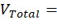 _______________
- Measure the potential difference across each resistor.
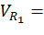_______________
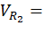_______________
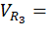_______________
- Add the potential difference across the individual resistors
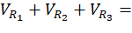_______________
- How does the value of Question 4 compare to the value of Question 2? What is the percent difference?

- Record the current on the ammeter.
_______________
- What do expect the current in each resistor to be? _______________
- Using the measured resistances and the measured current, calculate the total potential difference across the equivalent circuit.
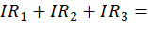 _______________
- How does the value in Question 8 compare to the value in Question 4? What is the percent difference?

- Which number equation (in the Theory Section) does Question 7 most illustrate? _______________

Part II Resistors in Parallel
Equivalent Resistance
Figure 8 Measurement of the effective resistance for the parallel circuit.
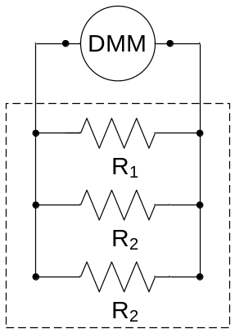

- Set the DMM to measure resistance.
- Connect the three resistors so that they are wired in parallel with the DMM as shown in Figure 8.
- What is the equivalent resistance of the three resistors? _______________
- Add the reciprocals of the resistances in Table 1.
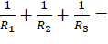 _______________
- Find the reciprocal of the sum in Number 4. _______________
- How do the values in Question 3 and Question 5 compare? What is the percent difference?
_______________%
- Of the four numbered equations (in the Theory Section), which one applies here? _______________

Part IV Parallel Resistors in Circuits
Figure 9 Resistor Circuit in Parallel
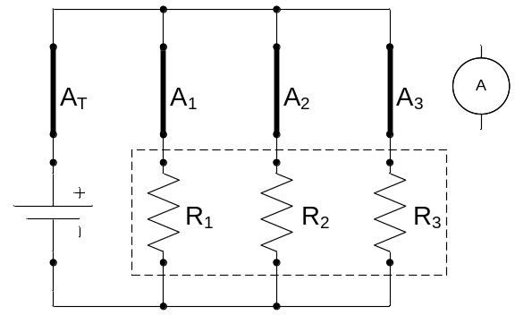

- Connect the three resistors in parallel as shown in Figure 9.
- Figure 9 shows four different locations where the ammeter will go for each of your measurements. This means you will have to move the one ammeter to get each measurement.
  - The ammeter should be set in the 200mADC scale and wired accordingly. Some DMMs may be different.
  - Set the battery eliminator ‘DC voltage Selector’ to 6 VDC.
  - Do not turn on the battery eliminator until your circuit has been checked by your professor or the lab technician. You will have four different circuits. Each one must be checked.
- Measure the potential difference across the battery eliminator. _______________
- What do you expect the potential difference across each resistor to be? _______________
- Place the ammeter successively in the circuit so that the current through the circuit and each individual resistor can be measured. Since you only have one ammeter, you will need to move it to make different measurements.
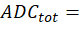 _______________
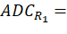 _______________
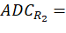 _______________
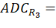 _______________
- Add the current through each of the resistors
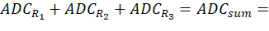 _______________
Compare to the total current _______________
What is the percent difference?
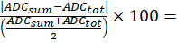 ______________%

Discussion Questions
Part I—Series Resistors
- Make a statement comparing the total potential difference of the circuit and the potential difference across the three resistors.

- Make a statement comparing the total current and the current going through each resistor.

Part II—Parallel Resistors
- Make a statement comparing the total potential difference of the circuit and the potential difference across the three resistors.

- Make a statement comparing the total current and the current going through each resistor.

How to read Resistor Color Codes

First the code
Black | Brown | Red | Orange | Yellow | Green | Blue | Violet | Gray | White
0 | 1 | 2 | 3 | 4 | 5 | 6 | 7 | 8 | 9


How to read the code
First find the tolerance band, it will typically be gold ( 5%) and sometimes silver (10%).
Starting from the other end, identify the first band - write down the number associated with that color.
Now 'read' and record the next color.
Now read the third or 'multiplier' band and write down that number of zeros.
If the 'multiplier' band is Gold move the decimal point one to the left. If the 'multiplier' band is Silver move the decimal point two places to the left. If the resistor has one more band past the tolerance band it is a quality band.
Read the number as the '% Failure rate per 1000 hour's of operation at full power load'. (To get better failure rates, resistors are typically specified to have twice the needed wattage dissipation that the circuit produces)
1% resistors have three bands to read digits to the left of the multiplier. They have a different temperature coefficient in order to provide the 1% tolerance.

